Đề thi IOE cấp huyện lớp 3 năm 2021 - 2022

1. ____ down, please.
2. has / Linda / books. / twenty / comic

…………………………………………………………………………

1. down ? / sit / and / I come / May / in

…………………………………………………………………………

1. is / old. / ten years / brother / His

…………………………………………………………………………

1. are Phuong and Lan yours sisters ? – Yes, ____ are.
2. We B. they C. she D. he
3. My grandmother ___ cooking.
4. Like B. likes C. liking D. is like
5. What / name ? / your / is / brother’s

…………………………………………………………………………

1. at / time. / play / Let’s / break / badminton

…………………………………………………………………………

1. _____ tennis. 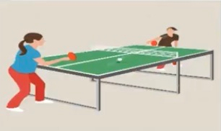
2. The ______ is very tidy.  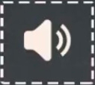
3. It’s a tr____gle. 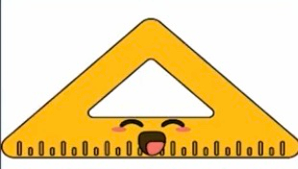
4. Is that your bed_____ ?
5. ____ that ? – It’s Mr Hoang.
6. Who B. Who’s C. what D. What’s
7. _____ds. 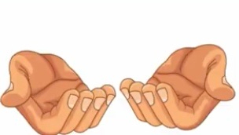
8. This is my ________.  
9. Which word has the underlined part pronounced like the letter “I” in HIS ?
10. Kite B. Rabbit C. Bike D. Five
11. Who are they ? – They are Peter ____ Marry.
12. With B. so C. but D. and
13. Which word has the underlined part pronounced like the letter “O” in WHO ?
14. Mother B. Go C. Too D. Brother
15. ____ is that ? – It’s Minh.
16. Is your brother old ? – No, He isn’t. He is very ____ .
17. Fat B. young C. thin D. tall
18. He ___ a teacher. He ____ a doctor. 
19. is – is B. is – isn’t C. isn’t – is D. isn’t – isn’t
20. is at / school / with her / now. / Lily / mother

…………………………………………………………………………

1. She / on / school / to / goes / foot.

…………………………………………………………………………

1. ___ you have any crayons ?
2. What colour ____ the wall ?
3. picture / again, / please. / the / Look at

…………………………………………………………………………

1. Which word has the underlined part pronounced like the letter “E” in TEN ?
2. New B. computer C. Teddy bear D. pencil sharpener
3. Is / the garden / your / now ? / cat in

…………………………………………………………………………

1. forty / My / years old. / uncle is

…………………………………………………………………………

1. Choose the INCORRECT word or phrase in the following setence : Do you like badminton, Mai ? – Yes, I don’t.
2. Do B. like C. yes D. I
3. break / time. / with her / chess / friends at / Emma plays

…………………………………………………………………………

1. four , five , ______ , seven
2. Mai has ten candies. Linh has fourteen candies. Mai and Linh have ____ - four candies.
3. Choose the odd one out :
4. Seven B. young C. Twenty D. Fifteen
5. What _____ is her school bag ? – It’s grey.
6. There is a ____ over there. 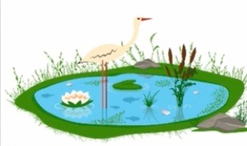
7. Pond B. lake C. river D. mountain
8. May I go ____ , Mr Hoang ?
9. How do you s____ your name ?
10. How / do / you / spell / “Annie” ?

…………………………………………………………………………

1. ____ that you mother ?
2. is B. Are C. Do D. Does
3. Tell / pet. / me / your / about

…………………………………………………………………………

1. I like oranges. ____ about you ?
2. pupil. / He / new / is / not a

…………………………………………………………………………

1. Choose the INCORRECT word or phrase in the following setence : She likes play badminton at break time.
2. Likes B. play C. at D. time
3. St__d up.
4. Tho___ are her notebooks.
5. Toby is _______ .  
6. Which word has the underlined part pronounced like the letter”A” in PLAY ?
7. Baby B. black C. classroom D. balloon
8. ____ many flowers in the garden.
9. There isn’t B. this is C. there are D. there is
10. This is / of / my / grandparents. / a photo

…………………………………………………………………………

1. reading / Be quiet, / a book / please. I / am

…………………………………………………………………………

1. The pond is in _____ of the house.
2. After B. behind C. front D. next
3. ___ to meet you.
4. Thank B. fine C. love D. pleased
5. Count ____ ten to twenty, please.
6. Choose the odd one out:
7. Game B. flower C. Song D. Repeat
8. It’s / big / a / lion. / Look!

…………………………………………………………………………

1. Qu__tion
2. doing at / like / break / What / time ? /do you

…………………………………………………………………………

1. My dad and I often ____ football.
2. Plays B. to play C. play D. playing
3. Can you play _____ guitar ?
4. book ? / this / Is / comic / your new

…………………………………………………………………………

1. music / I sing / room. / a song / in the

…………………………………………………………………………

1. ____ this your rubber, Mai ?
2. Are B. Is C. Do D. Does
3. Tell me _______ your mother.
4. Is your school big ? – Yes, ____ is.
5. It’s a _____cle. 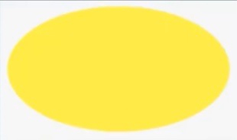
6. bookcase / next to / The / is / the desk

…………………………………………………………………………

1. computer / Is / room / large ? / the

…………………………………………………………………………

1. can you ride a _____ ? 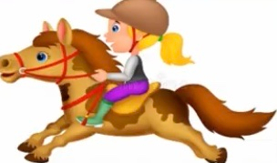
2. train B. horse C. bike D. motorbike
3. colour / the pencil / sharpener ? / is / What

…………………………………………………………………………

1. It’s a present ____ you, Mai.
2. For B. with C. to D. of
3. These _____ my hats.
4. Ted is _____ the boat.
5. In B. on C. at D. of
6. ___ any school things on the desk ?
7. Is there B. are there C. Do there D. Does there
8. ___ is very beautiful.
9. Linh is bedroom C. Bedroom’s Linh
10. Linh’s bedroom D. Linh bedroom
11. The bus is _______.  
12. Look at the picture and choose the best answer. 
13. It’s sunny. B. it’s cold. C. It’s windy. D. It’s rainy.
14. What ___ Lily do at break time ?
15. case. / pen is/ my pencil / The / not / in

…………………………………………………………………………

1. clips / green ? / your / paper / Are

…………………………………………………………………………

1. This is a pic____e of my bedroom.
2. bed. / are / under / My / puppets / the

…………………………………………………………………………

1. Is your grandmother ____ the kitchen ?
2. old ? / Are / nine / years / you

…………………………………………………………………………

1. They are playing hide-and-_____k.
2. my house. / is a / pond / There / behind

…………………………………………………………………………

1. It’s / to meet / nice / you.

…………………………………………………………………………

1. is / That / little / my / girl / sister.

…………………………………………………………………………

1. G____night
2. Let’s / basketball / after / school. / play

…………………………………………………………………………

1. you / monkeys ? / like / Do

…………………………………………………………………………

1. It’s a s___re. 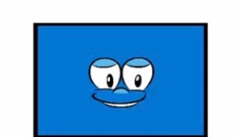
2. Choose the letter(s) to make a correct word: GR___MOTHER
3. AND B. ANT C. AOR D. AMN
4. B______. 
5. Your school bag is _____. 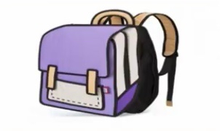
6. Black B. yellow C. green D. purple
7. How / grandmother ? / old is / your

…………………………………………………………………………

1. How do / spell / your aunt’s / you / name ?

…………………………………………………………………………

1. Choose the letter(s) to make a correct word : N_XT
2. O B. E C. A D. U
3. Lan is / her uncle. / next to / The / man

…………………………………………………………………………

1. Is that your teacher ? - ____.
2. Yes, it does. B. No, it doesn’t C. yes, it is D. No, it is.
3. Is that your teddy bear ? - ___, it isn’t.
4. Are there three frogs in the picture ?
5. Yes, there are. C. No, there are.
6. C. No, there is. D. Yes, there have.
7. Is that your teddy bear ? - __, it isn’t.
8. Are there three frogs in the picture ?
9. Yes, there are. C. No, there are.
10. No, there is. D. Yes, there have.
11. The ball is ____ the slide.
12. ____ is the boy on the bike ? – It’s Nam.
13. Who B. Which C. What D. When
14. gives / me / a new / bookcase. / My brother

…………………………………………………………………………

1. your / Talk / family with / about your / classmate.

…………………………………………………………………………

1. Tom has twenty blue pens. Mai has five pink pens. Linh has ten black pens and seven pink pens. Mai and Linh have _______ pink pens.
2. Goodbye. See you _____ .
3. Late B. later C. now D. so
4. Choose the letter(s) to make a correct word: SI__Y
5. SB B. XM C. ST D. XT
6. B__own.
7. The computer room is new b___ small.
8. Look at those ______. 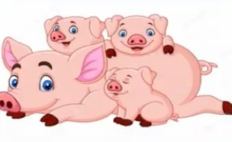
9. Do you visit your grandma ____ the weekend ?
10. On B. at C. in D. with
11. The library is ______.  
12. Is ____ classroom large ?
13. He B. him C. you D. your
14. ____ to meet you, Miu.
15. ____ you like carrots, Billy ?
16. old / school / library is / but / large. / The

…………………………………………………………………………

1. this is my _____ .
2. pens B. books C. brothers D. sister
3. is / my / This / lion. / paper

…………………………………………………………………………

1. Where / your / sister / is / now ?

…………………………………………………………………………

1. classmates / Tell your / bedroom. / about / your

…………………………………………………………………………

1. five plus ten makes ____.
2. Sixty B. sixteen C. fifteen D. fifty
3. There are five ______. 
4. Colours B. stars C. robots D. animals
5. My grandfather _____ today.
6. Goes to fishing C. goes fish
7. Go fishing D. goes fishing
8. Linda is in the music room now. She likes _____ .
9. Dancing B. painting C. singing D. drawing
10. her books / These / are / and / pens.

…………………………………………………………………………

1. choose the odd one out:
2. Paper boat B. Library C. Classroom D. Computer room
3. Are / Nam’s / friends ? / they

…………………………………………………………………………

1. These are ____ . 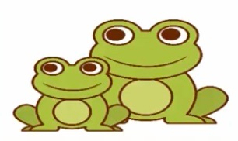
2. Penguins B. dolphins C. octopuses D. frogs
3. The ____ is not big. 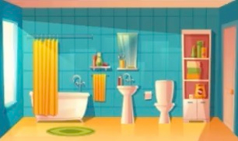
4. Bedroom B. bathroom C. kitchen D. living room
5. T_____ me about your friends.
6. This is my desk. It’s _____. 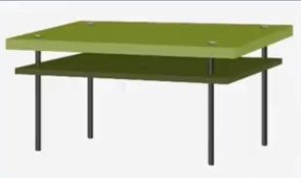
7. Bas____ball
8. How old is _____ ? – he is 45 years old.
9. Your sisters B. your uncle C. your brothers D. your aunts
10. Do you like football, Hung ? – Yes, I ____.
11. Tony is my friend. He is eight _______.
12. Years old B. old years C. years D. olds
13. See you s__n.
14. Forty plus twenty makes ____.
15. Fifty B. sixty C. seventy D. eighty
16. her / purple / these / notebooks ? / Are

…………………………………………………………………………

1. I have a green pencil _____ pener.
2. Her grandmother is _____ years old.
3. Seventeen- eight C. eight-seventy
4. Seventy-eight D. eight- seventeen
5. Is / your / father / years old ? / forty

…………………………………………………………………………

1. I have a lunch ____. 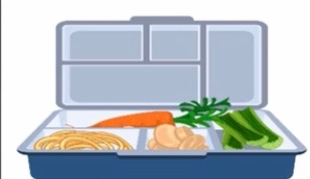
2. football / play / time. / They / at break

…………………………………………………………………………

1. yellow ? / Is / bookcase / your

…………………………………………………………………………

1. How many pupils _____ in your classroom ?
2. There are B. is there C. are there D. there is
3. ____h your teeth twice a day.
4. We ___ skipping. We like ____.
5. Are not like – skate C. are not like – skating
6. Do not like – skating D. does not like – skating
7. Don’t / book. / your / close

…………………………………………………………………………

1. W__te
2. very big. / The / room / living / is

…………………………………………………………………………

1. are / twenty / class. / girls / in my / There

…………………………………………………………………………

1. monkey. / make / a paper / Let’s

…………………………………………………………………………

1. My sister is ____. She is also beautiful. 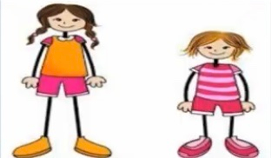
2. Tall B. seven C. fat D. eight
3. class / Sit / down, / please. / Hi,

…………………………………………………………………………

1. Pur __e
2. ___ is there next to your pencil ? – It’s a glue.
3. What B. Which C. When D. Who
4. in / father is / now. / the yard / My / not

…………………………………………………………………………

1. can’t / I / on / the pen / the chair. / see

…………………………………………………………………………

1. __ does Marry do at break time ? – She plays badminton.
2. What B. How C. Which D. When
3. ____ are you ? – I’m ten years old.
4. When B. How C. What old D. How old
5. Listen and tick.  
6. fish B.kitten C. kitchen D. garden
7. _______ . 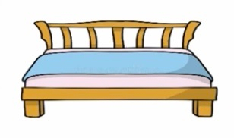
8. These are my _____ things: rulers, pens, pencils, books ...
9. train / is / big. / very / Nam’s

…………………………………………………………………………

1. ____ the library big and new ?
2. Is B. Are C. Do D. does
3. Look at these ______. They are new. 
4. Notebooks B. photos C. televisions D. computers
5. There are _____eyes on my face.
6. Which word has the underlined part pronounced like the letter “O” in GO ?
7. Cold B. Colour C. Orange D. Long
8. Mai is ______ing with her friends. 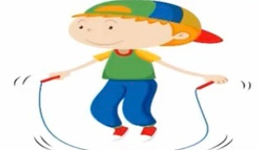
9. ____ Huong and Nam your new friends ?
10. They / and Lily. / are / Anna

…………………………………………………………………………

1. There are two ______. 
2. Be q____et, Lily !
3. There are _____ fingers on two hands.
4. How ____ is your grandmother ? – She’s 60.
5. Look at that Christmas tree. _____ beautiful.
6. It are B. They are C. It’s D. They’re
7. ice / She / cream. / not / like / does

…………………………………………………………………………

1. Are those your pencil _____ pens ?
2. girl is / The / old. / four / years / little

…………………………………………………………………………

1. _______ . 
2. They / her / sharpeners. / pencil / aren’t

…………………………………………………………………………

1. My pencils are not _____. They are short.
2. bedroom. / in / is / my / The kitten / Look !

…………………………………………………………………………

1. _____ is my father.
2. Those B. They C. This D. These
3. She’s beautiful. And who’s this ? – It’s my elder brother. His name is Trung.
4. ... is that? – That’s Marry. She is my friend.
5. How B. When C.Who D.Where
6. Your brother’s/ at/ the desk./ ball/ is

=> Your brother’s is at the desk.

1. May I go out?- ...
2. Hello B. Nice to meet you C. Fine,thanks D. Sure
3. What are ... ? ... cassettes.
4. They/ there are B. They/ it’s C. This / it’s D. These/ they’re
5. Aloud/ Read/ and/ sit down. /then

=>Read aloud and the sit down.

1. Are there/ students/ in/ your classroom?/ How many

=>How many students are there in your classroom?

1. That _ _ _ over there is Mr Nam.
2. There are two clocks _ _the table,
3. What color ... her pens? - .... green and red.

A.Is/ it’s C. Are/ there are

1. Are/ they’re D.Is / they’re